ScanTool User Manul
Scan Device: When using RJ45 (TCP/IP), click "Scan Device" to query the device IP address, Mac address, port, netmask, gateway, etc.

1.Open the software V1.2 or above, click “Scan device”
Note: It is necessary to open the software V1.2 or above (including V1.2)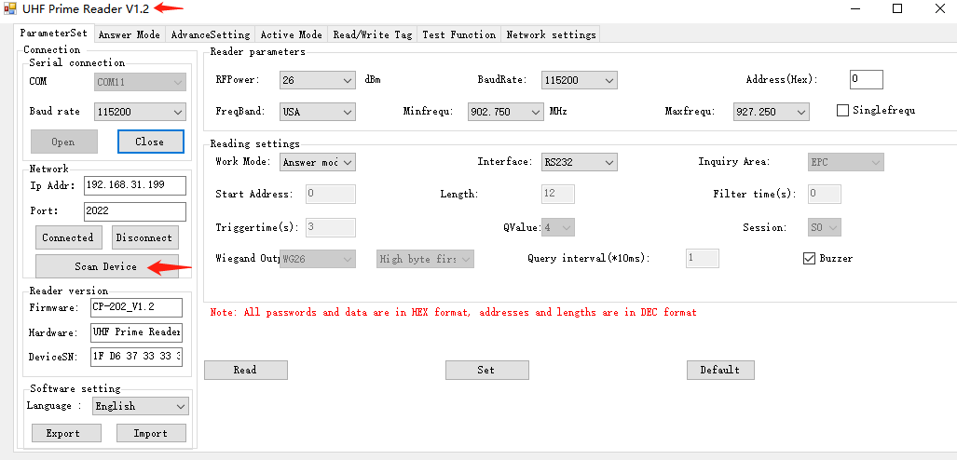

2.Search window will pop up, click to “start “
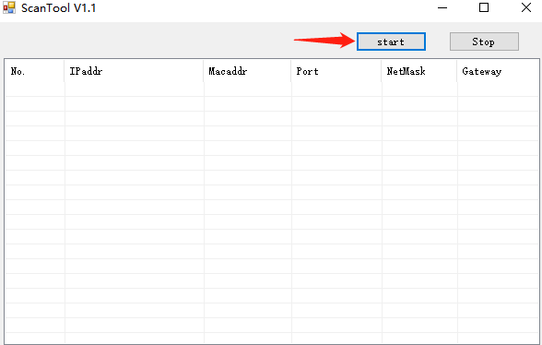

3.After searching for the device, the IP address, Mac address, port, netmask, gateway will be displayed, double-click the data to be modified；
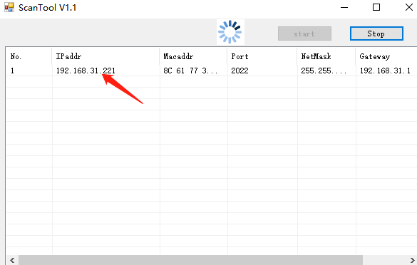

3.1 If the device IP and the local IP are not in the same network segment, you need to modify the local device IP and the device IP to be in the same network before setting.
For example, the local ip is 192.168.1.100 (the network segment is 192.168.1), the card reader ip is 192.168.31.201 (the network segment is 192.168.31), and the local ip address needs to be changed to the same network segment as the card reader.

Setting method：
Control Panel\Network and Internet\Network Connections
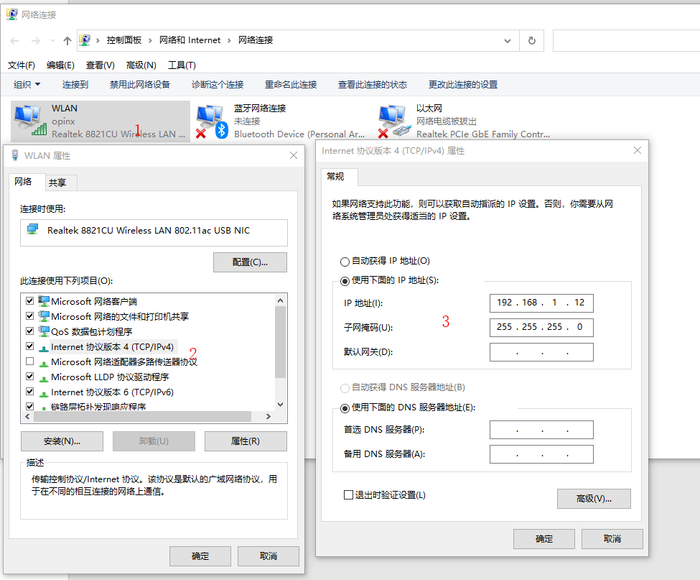

4.The modification window pops up, after modifying the data, click SET；
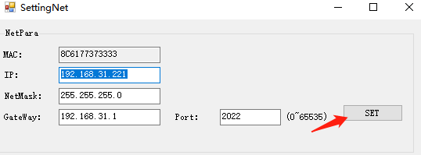
4，Set successfully
